**DB ||**

Day2 || 15 july 2022

—---------------------------------------------------------------------------------------------------------

**ER DAIGRAM**

Entity

Attributes

Relationship

Strong

Weak

Degree of relationship

Unary

Binary

Mapping cardinality

One to one

eg.citizen has Aadhar card

One to many === many to one

Eg. Citizen has vehicle || courses are enrolled by student

Many to many

Eg.customer and products

**Participation constraints:minimum cardinality constraints**

Participation Total **–** Each entity in the entity set **must participate** in the relationship. If each student must enroll in a course, the participation of student will be total. Total participation is shown by double line in ER diagram.

Partial Participation **–** The entity in the entity set **may or may NOT participat**e in the relationship. If some courses are not enrolled by any of the student, the participation of course will be partial.

Entity type || weak Entity || weak relationship

**Weak entity always comes with total partici[ation constarints with strong entity.**

**Extended ER Daigram**

Specialization

Is-a-relationship

Top-down approach

Generalization

================

Attribute Inheritance

Participation inheritance

**Aggregation:**

[Lecture 4: Extended ER Features || Abstraction in ER Model](https://youtu.be/8_dMPX6_qiY?list=PLDzeHZWIZsTpukecmA2p5rhHM14bl2dHU)

**Assignment 1:**

**Qus: create table FB_USERs and put a check for age >=18 in it??**

/*******

ALTER TABLE table_name ADD CONSTRAINT constraint_name CHECK (column_name condition);

ALTER TABLE Persons

ADD CHECK (Age>=18);

THIS IS FOR MY REFERENCE *************/

**HERE I CAN PUT CONSTRAINTS AT THE TIME OF TABLE CREATION ..**

**BUT I TRIED TO PUT CONSTARINTS IN EXISTING TABLE**

**FROM HERE COMMADLINE STATEMENTS STARTS:**

**mysql> use database sampledb;**

**ERROR 1049 (42000): Unknown database 'database'**

**mysql> use sampledb;**

**Database changed**

**mysql> create table FB_USERS(ID INT,NAME VARCHAR(15), CITY VARCHAR(10)**

**-> ,COUNTRY VARCHAR(15),AGE INT);**

**Query OK, 0 rows affected (0.06 sec)**

**mysql> DESC FB_USERS;**

**+---------+-------------+------+-----+---------+-------+**

**| Field | Type | Null | Key | Default | Extra |**

**+---------+-------------+------+-----+---------+-------+**

**| ID | int | YES | | NULL | |**

**| NAME | varchar(15) | YES | | NULL | |**

**| CITY | varchar(10) | YES | | NULL | |**

**| COUNTRY | varchar(15) | YES | | NULL | |**

**| AGE | int | YES | | NULL | |**

**+---------+-------------+------+-----+---------+-------+**

**5 rows in set (0.00 sec)**

**mysql> ALTER TABLE FB_USERS ADD CONSTRAINTS CHECK(AGE AGE>=18);**

**ERROR 1064 (42000): You have an error in your SQL syntax; check the manual that corresponds to your MySQL server version for the right syntax to use near 'CHECK(AGE AGE>=18)' at line 1**

**mysql> ALTER TABLE FB_USERS ADD CHECK( AGE>=18);**

**Query OK, 0 rows affected (0.12 sec)**

**Records: 0 Duplicates: 0 Warnings: 0**

**mysql> INSERT INTO FB_USERS(ID,NAME,CITY,COUNTRY,AGE) VALUES (101,'DEVANSH','KANPUR'**

**-> ,'INDIA',22);**

**Query OK, 1 row affected (0.01 sec)**

**mysql> INSERT INTO FB_USERS(ID,NAME,CITY,COUNTRY,AGE) VALUES (102,'ASHI','GZBD','INDIA',17);**

**ERROR 3819 (HY000): Check constraint 'fb_users_chk_1' is violated.**

**mysql> SELECT * FROM FB_USERS;**

**+------+---------+--------+---------+------+**

**| ID | NAME | CITY | COUNTRY | AGE |**

**+------+---------+--------+---------+------+**

**| 101 | DEVANSH | KANPUR | INDIA | 22 |**

**+------+---------+--------+---------+------+**

**1 row in set (0.00 sec)**

**mysql>**

**========================================================**

**Assignment 2:**

**Ques: add a email column along with the validation of it moust contains @ and . in it??**

**mysql> DESC FB_USERS;**

**+----------+-------------+------+-----+---------+-------+**

**| Field | Type | Null | Key | Default | Extra |**

**+----------+-------------+------+-----+---------+-------+**

**| ID | int | YES | | NULL | |**

**| NAME | varchar(15) | YES | | NULL | |**

**| CITY | varchar(10) | YES | | NULL | |**

**| COUNTRY | varchar(15) | YES | | NULL | |**

**| AGE | int | YES | | NULL | |**

**| EMAIL_ID | varchar(20) | YES | | NULL | |**

**+----------+-------------+------+-----+---------+-------+**

**6 rows in set (0.00 sec)**

**mysql> ALTER TABLE FB_USERS ADD CONSTRAINTS EMAIL_CONSTRAINT CHECK (EMAIL_ID LIKE %___@__%.___%);**

**ERROR 1064 (42000): You have an error in your SQL syntax; check the manual that corresponds to your MySQL server version for the right syntax to use near 'EMAIL_CONSTRAINT CHECK (EMAIL_ID LIKE %___@__%.___%)' at line 1**

**mysql> ALTER TABLE FB_USERS ADD CONSTRAINT EMAIL_CONSTRAINT CHECK (EMAIL_ID LIKE %___@__%.___%);**

**ERROR 1064 (42000): You have an error in your SQL syntax; check the manual that corresponds to your MySQL server version for the right syntax to use near '%___@__%.___%)' at line 1**

**mysql> ALTER TABLE FB_USERS ADD CONSTRAINT EMAIL_CONSTRAINT CHECK(EMAIL_ID LIKE %___@__%.___%);**

**ERROR 1064 (42000): You have an error in your SQL syntax; check the manual that corresponds to your MySQL server version for the right syntax to use near '%___@__%.___%)' at line 1**

**mysql> ALTER TABLE FB_USERS ADD CONSTRAINT EMAIL_CONSTRAINT CHECK(EMAIL_ID LIKE %___@__%);**

**ERROR 1064 (42000): You have an error in your SQL syntax; check the manual that corresponds to your MySQL server version for the right syntax to use near '%___@__%)' at line 1**

**mysql> ALTER TABLE FB_USERS DROP COLUMN EMAIL_ID;**

**Query OK, 0 rows affected (0.04 sec)**

**Records: 0 Duplicates: 0 Warnings: 0**

**mysql> ALTER TABLE FB_USERS ADD EMAIL_ID VARCHAR (20) CHECK (EMAIL_ID like %@% AND EMAIL_ID like %.%);**

**ERROR 1064 (42000): You have an error in your SQL syntax; check the manual that corresponds to your MySQL server version for the right syntax to use near '%@% AND EMAIL_ID like %.%)' at line 1**

**mysql> ALTER TABLE FB_USERS ADD EMAIL_ID VARCHAR(20) CHECK(EMAIL_ID like %@% AND EMAIL_ID like %.%);**

**ERROR 1064 (42000): You have an error in your SQL syntax; check the manual that corresponds to your MySQL server version for the right syntax to use near '%@% AND EMAIL_ID like %.%)' at line 1**

**Correct one here:**

**mysql> ALTER TABLE FB_USERS ADD EMAIL_ID VARCHAR(20) CHECK(EMAIL_ID like "%@%" AND EMAIL_ID like "%.%");**

**Query OK, 1 row affected (0.10 sec)**

**Records: 1 Duplicates: 0 Warnings: 0**

**mysql> INSERT INTO FB_USERS (ID,NAME,CITY,AGE,EMAIL_ID) VALUES(11056,'DEVANSH','KANPUR','INDIA',22,'MRDEV727@GMAIL.COM');**

**ERROR 1136 (21S01): Column count doesn't match value count at row 1**

**mysql> INSERT INTO FB_USERS (ID,NAME,CITY,COUNTRY,AGE,EMAIL_ID) VALUES(11056,'DEVANSH','KANPUR','INDIA',22,'MRDEV727@GMAIL.COM');**

**Query OK, 1 row affected (0.01 sec)**

**mysql> INSERT INTO FB_USERS (ID,NAME,CITY,COUNTRY,AGE,EMAIL_ID) VALUES(11056,'DEVANSH','KANPUR','INDIA',22,'MRDEV727@GMAILCOM');**

**ERROR 3819 (HY000): Check constraint 'fb_users_chk_2' is violated.**

**===================================================================**

**Assignment 3**

**What is Agreegation ?? example??**

**Aggregation is a term of extended ER diagram that is used to show relationships between other relationships.**

**Aggregation creates a abstract view of entities& relationship for new relationship**

**Basically our normal ER diagram was not able to represent such relationships among relationship that’s why it is introduced into EER diagram.**

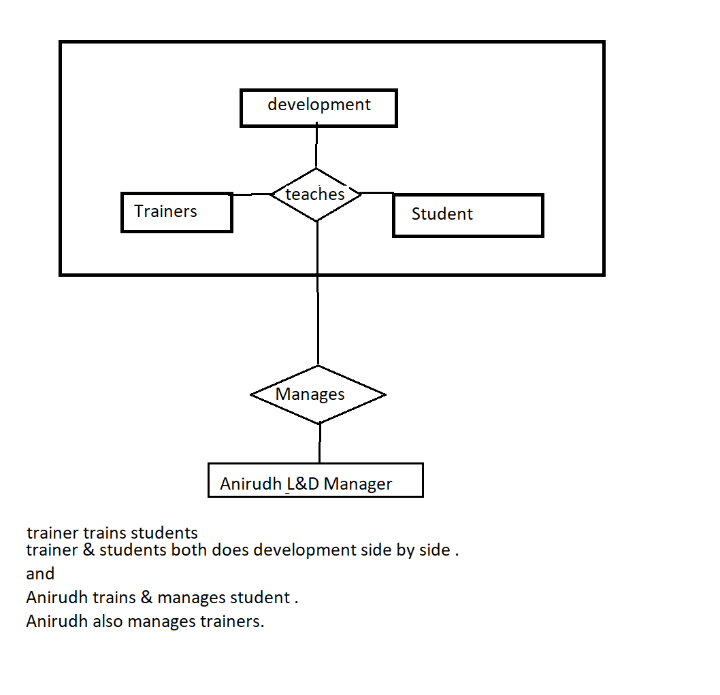

Anirudh also does development side by side.

**========================================================**

**Assignment 5**

**ER diagram for Library management System**

**Entities:**

**Books,Members,staff,Librarian ,Helper,Borrow/Return Record,author,publisher**

**Attributes:**

**books:**book_id,book_name,cost,rating

**Author:** Author_id,Author_name,specialization,experience

**Publisher:** pub_id,pub_name,place,date_Of_publish

**Member:** member_id,member__typeCode,

**User:**user_id,user_name,address,contact,membership

**Staff:** staff_id,staff_name,dept,salary

**Helper:** helper_id,help_name

**Librarian:** lib_id,lib_name

**borrow/return Record:** ref_ID,operation_type,date_of_borrow,date_of_return,amount

**Membership:** mem_id,start_date,expiration date

**Relationship:**

**Member borrow/returns book. M:n || total**

**Author writes books. == m:n**

**Publishers publishes books == || 1:n**

**Member takes membership.** == || 1:1

